**Business Scenario**

AAVAIL launched using a tiered, subscription-based service which showed promise, but conversations with users, especially those outside of US markets, prompted an experiment using an *à la carte* approach. This experiment was carried out mostly outside of the US and there are now a couple of years of data with a few thousand active users. The data are transaction-level purchases across 38 different countries and are invoiced in batches.

Management has nearly decided to make the switch to the new model, but they find it difficult to **predict monthly revenue**. They have asked you to create a service that, at any point in time, will predict the revenue for the **following month**. They have also asked that the service be given the ability to project revenue for a **specific country**. To keep the development time reasonable you have been advised to limit your model to the **ten countries with the most revenue**.

Managers are confident that this product will have a **meaningful business impact**. Currently, these managers are using their own methods to predict revenue, but they have come to feel that they are spending too much time on this and their lack of expertise in data science means their predictions are not as accurate as they would like. The management team expects to spend less time creating their own projection models, and they expect the new results to be more **accurate**.

They have assured you that well-projected numbers will help stabilize staffing and budget projections which will have a beneficial ripple effect throughout the company.

**Hypotheses**

1. Is the predicted monthly revenue in the top 10 country’s higher within the new product then in the current product?
   1. What are the 10 country’s with the most revenue?
   2. Can we predict monthly revenue for each specific country, that is more accurate then the current models used by the managers?

**Data**

We’d need the predicted and actual revenue from the past years to test if the new model is actually predicting more accurate then the managers. Also we need date for both the new product as the current product, to see the difference in revenue and conclude if the predicted revenue is more.

For the model itself we’d need a dataframe with at least the following features:  
as price per product  
how many products per customer  
date/time of purchase  
country

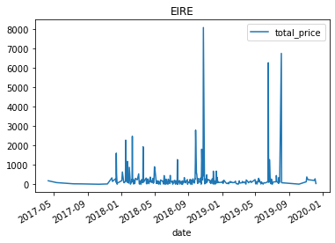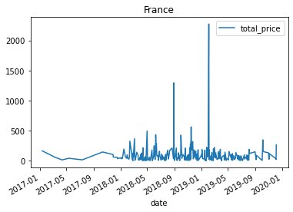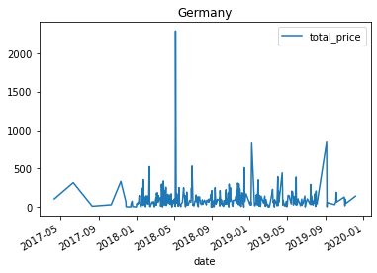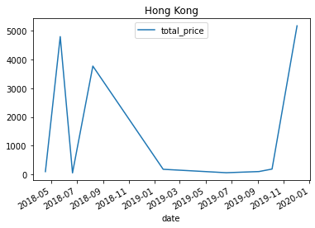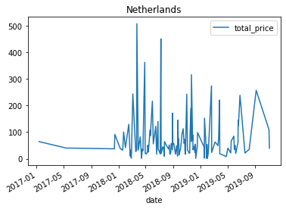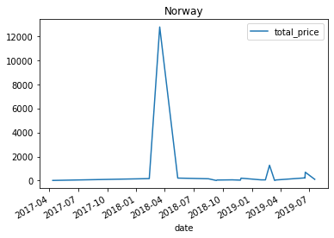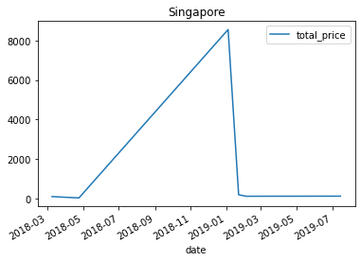

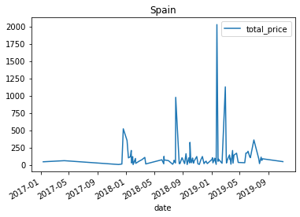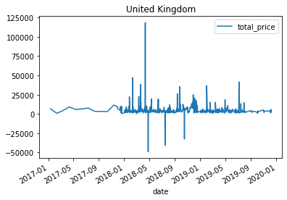

1. State the different modeling approaches that you will compare to address the business opportunity.
2. Iterate on your suite of possible models by modifying data transformations, pipeline architectures, hyperparameters and other relevant factors.
3. Re-train your model on all of the data using the selected approach and prepare it for deployment.
4. Articulate your findings in a summary report.